How to upload an Abstract and Full paper for ICFE 2018 conference?
This manual will guide you through the process of an abstract and a full paper submission.
______________________________________________________________________________
1) Go to “Paper submission” page on ICFE 2018 website follow the link: http://icfe2018.tdtu.edu.vn/paper-submission and click “Submit” bottom.
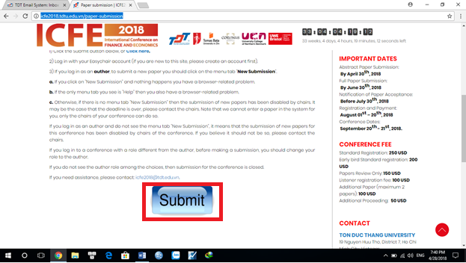
2) Log in to the EasyChair system with your user name and generated password. If you don’t have any user name before, please click to “create an account” and do some steps to make a new EasyChair account.
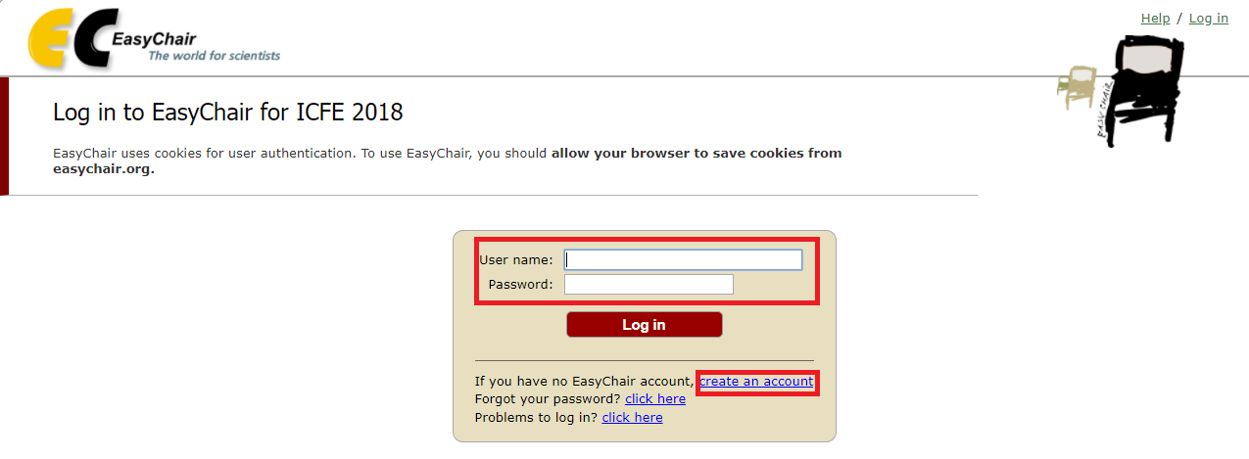

3) After log in to the EasyChair system, click to “enter as an author” to submit abstract and full paper to ICFE 2018 conference.
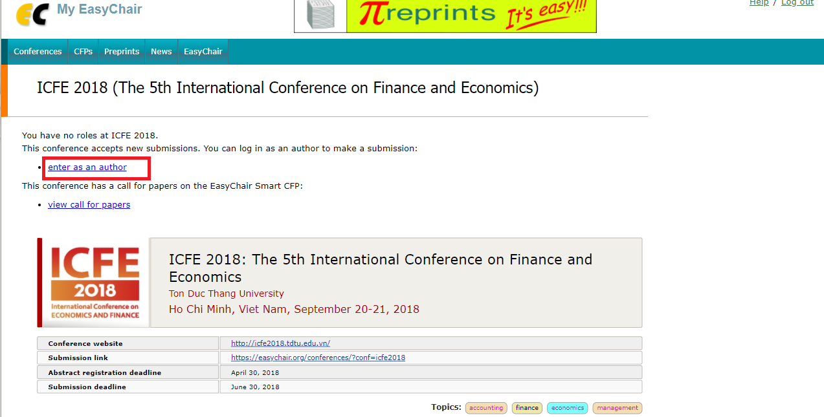

4) In each “New Submission”, EasyChair requests the author to give basic information of the paper, including the Abstract. Please fill all the requested fields for each “New Submission”, include the abstract contents, then click “submit”.

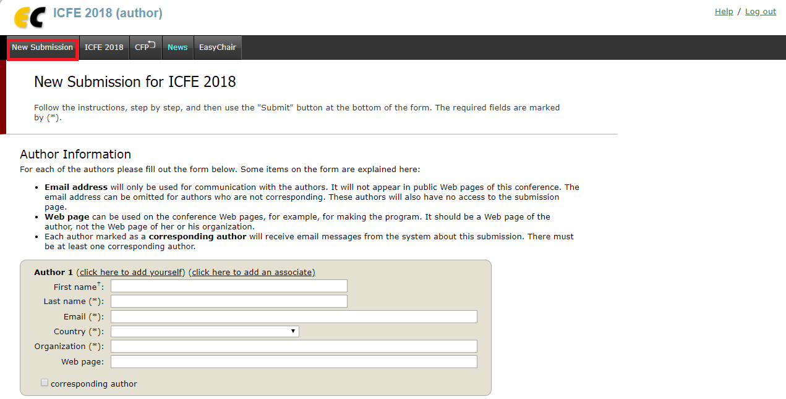

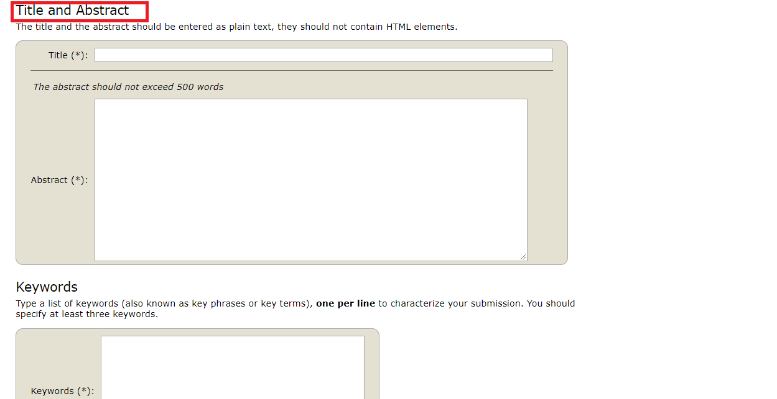

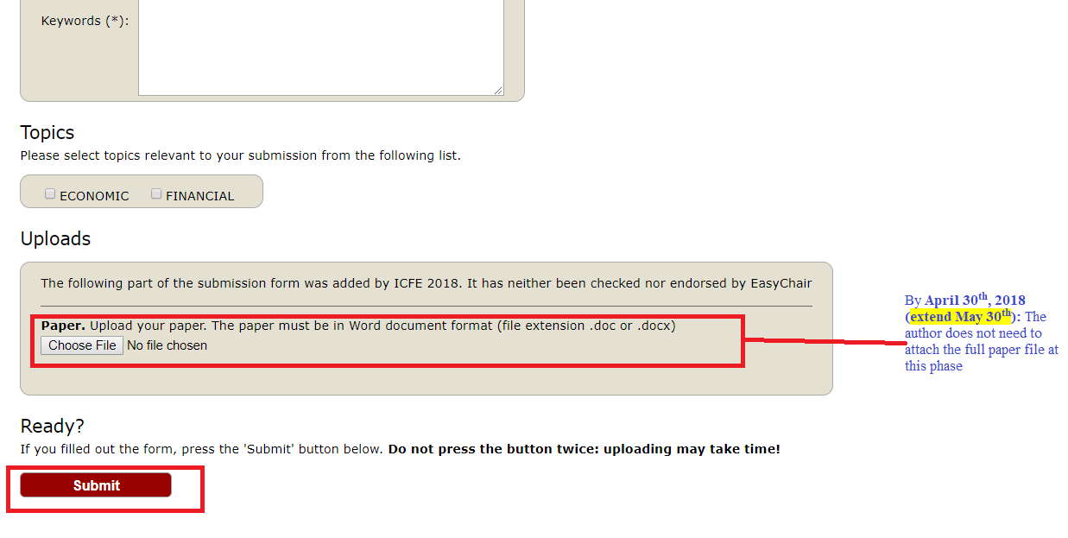
- Abstract Submission: By April 30th, 2018 (extended May 30th): The author does not need to attach the full paper file at this phase.
- Full Paper Submission: By June 30th, 2018: To complete the submission, the author once again log-in to EasyChair account and add file by attaching the full paper. The submission is then finished.
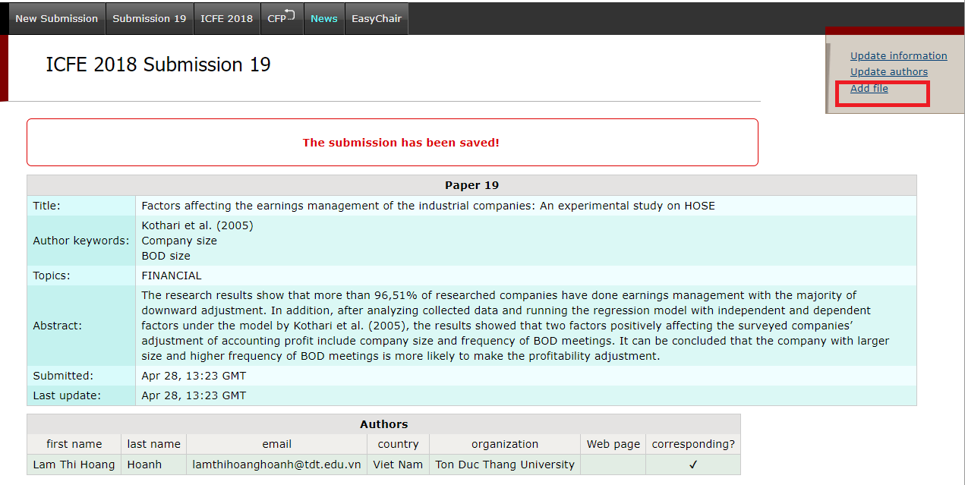

* Note: In case the author has already attached the Abstract as a separated file, it is still acceptable. Please note that to update file later, the author just need to replace the abstract file by the full paper file.

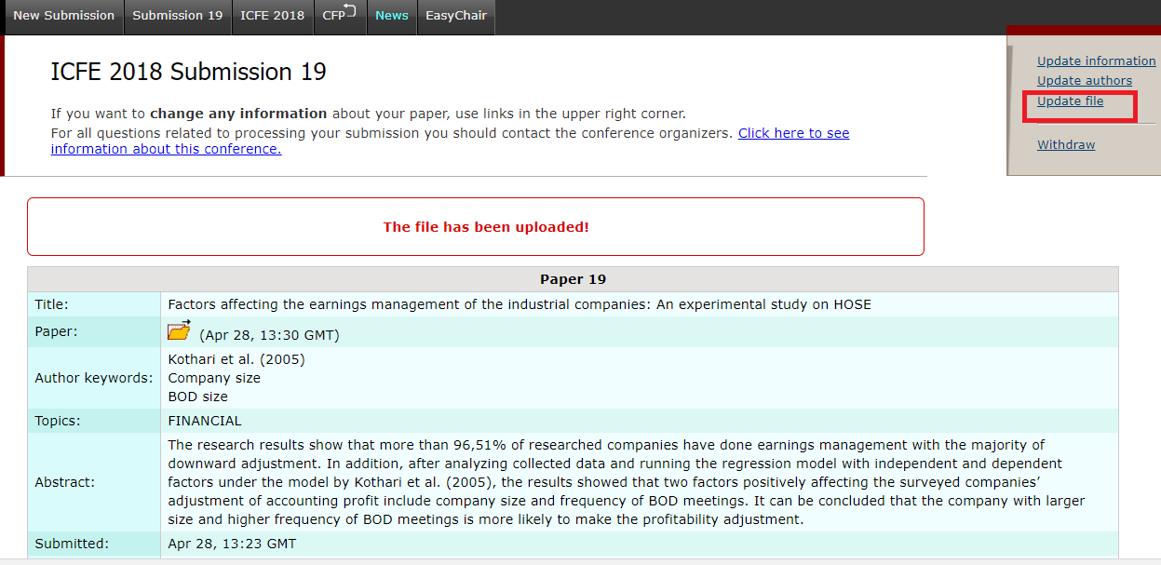
In the process of submission, should the author find any difficulty, please contact us for further support via icfe2018@tdt.edu.vn.

